Recipe 001: Writing SEO-Friendly Blog posts that Convert
Follow this simple 3-step recipe to start writing SEO friendly blog posts that rank on search engines and help you achieve your business goals.
Last Updated / Reviewed: 09/24/2023

🚀 Goal: Writing a blog post that not only attracts the right kind of audience but also converts them into customers.
🤞 Ideal Outcome: Part of the recipe assumes you’re using WordPress on your blog. But you can perform the equivalent actions on your own CMS.
🤔 Why this is important: Without a proper strategy backing up your blog posts you’ll spend a considerable amount of time writing content that will not help you achieve any of your goals.
🗓️ When this is done: Every time you want to write a new blog post.
👨 Who does this: Joint effort between the person responsible for SEO and Content.

Click here to get the most up-to-date version of this Recipe

Step 1 - Grab your keyword research spreadsheet (or perform keyword research if you don’t have done it yet)
SOP 011: How to Do Keyword Research for SEO (web version)
Outcome: You have defined the exact keyword that you want to target with your blog post.
Special instructions: To be more efficient, you should perform comprehensive keyword research once every few months covering a large range of topics. Then, once you pick what you’re going to write about, perform in-depth keyword research on that specific topic.

Step 2 - Create an awesome blog post outline
SOP 016: How to create awesome blog posts outlines (web version)
Outcome: You have completed the Outline Template and went through the General Blog Post Checklist included in the same SOP.

Step 3 - Perform on-page optimization on your blog post
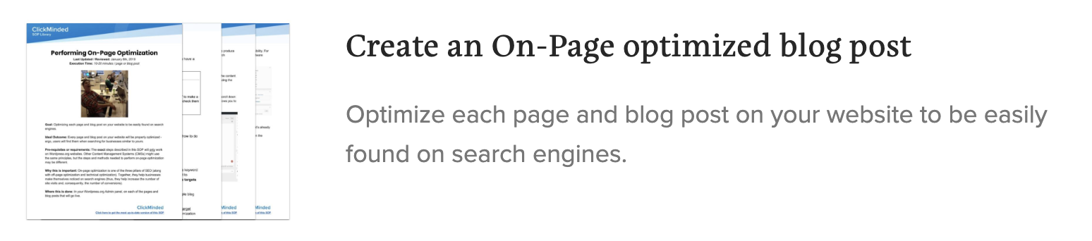
SOP 018: Perform on-page optimization on a WordPress post with Yoast (web version) / SOP 107: Perform on-page optimization on a WordPress post with RankMath (web version) / SOP 103: Optimize WordPress post with SEOPress (web version)
Outcome: You’ve perfectly optimized the content of your post for search engines.

